Supporting Information

Engineering Wafer-Scale Epitaxial Two-Dimensional Materials through Sapphire Template Screening for Advanced High-Performance Nanoelectronics

Yuanyuan Shi¹*, Benjamin Groven¹, Jill Serron¹, Xiangyu Wu^{1,2}, Ankit Nalin Mehta^{1,3}, Albert Minj^{1,3}, Stefanie Sergeant¹, Han Han¹, Inge Asselberghs¹, Dennis Lin¹, Steven Brems¹, Cedric Huyghebaert¹, Pierre Morin¹, Iuliana Radu¹, Matty Caymax¹

¹ IMEC, Kapeldreef 75, 3001 Leuven, Belgium
² Department of Materials Engineering, KU Leuven, Kasteelpark Arenberg 44, 3001 Leuven, Belgium
³ Department of Physics and Astronomy, KU Leuven, Celestijnenlaan 200d, 3001 Leuven, Belgium
* Email: yuanyuan.shi@imec.be

Keywords: transition metal dichalcogenides, metal-organic chemical vapor deposition, epitaxial growth, sapphire template, uniformity, field effect transistors, device-to-device variability

This file includes Figure S1-S30 and Table S1-S2.
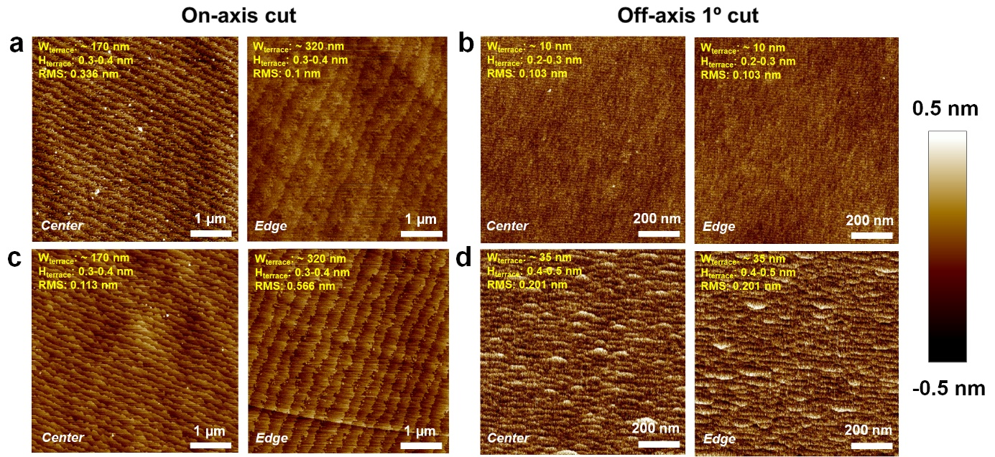

Figure S1. Sapphire terrace structure before and after the pre-epi treatment process. The sapphire surface before and after the O₂ annealing at 1175 ℃ for 1 hour. AFM topography of (a) on-axis and (b) off-axis 1º cut sapphire collected at the 2-inch wafer center and edge before annealing. (c-d) AFM topography of on-axis and off-axis 1º cut sapphire collected at the 2-inch wafer center and edge after annealing, respectively. The W_{terrace} and H_{terrace} increase and there is bunched steps formed after the annealing process for the off-axis 1º cut sapphire, while they doesn’t show obvious changes before and after annealing for on-axis cut sapphire. The step bunching is easier to happen of the narrow terraces.

Figure S2. Terrace orientation on on-axis cut and off-axis 1º cut sapphire. (a) Digital image of a 2-inch c-plane sapphire indicates the locations of center and different edges that are characterized by AFM in Figure 1. Schematic of the terraces on (b) off-axis 1º and (c-d) on-axis cut 2-inch sapphire wafers. It is worth to note that all the sapphire wafers are placed as it is shown in a for AFM scan, and the AFM characterization is performed with a tip scan rotation of 0º. The terrace orientation and width on (c-d) the on-axis cut sapphire differ within one wafer and from wafer to wafer.

The terrace orientations of on-axis cut sapphire can be different within and across the wafers as shown in Figure S2c-d, due to the uncontrolled mis-cut angle, while the terrace orientation of off-axis 1º cut sapphire is constant as shown in Figure S2b, since the off-axis cut angle is towards the constant direction (A-axis in this work) and larger than mis-cut angle (± 0.1º)

Figure S3. Sapphire terrace of another 2-inch wafer of on-axis and off-axis 1º cut sapphire. AFM topography of the on-axis cut sapphire at (a) center and (b) edge of the wafer. (c) Zoom-in image of (b). The W_{terrace} and H_{terrace} differ from the center to edges. Moreover, the W_{terrace} and H_{terrace} of this wafer is very different from on-axis cut sapphire wafer shown in Figure 1a, indicating the surface variability of the on-axis cut sapphire from wafer to wafer. (d-f) AFM topography of off-axis 1º cut sapphire from center to edges, indicating the uniformity of sapphire terrace structure within the wafer and also from wafer to wafer (compared with Figure 1b).

Figure S4. Another batch (named as Batch B here, compared to that in Figure S1b,d, name as Batch A) of off-axis 1º cut sapphire before and after O₂ annealing at 1175 ℃ for 1 hour. AFM topography maps of the off-axis 1º cut sapphire from center to edges (a) before and (b) after pre-treatment process. Compared to the surface structure of off-axis 1º cut sapphire from Batch A in Figure S1b, the sapphire surface looks slightly different for the ones before pre-treatment since no terrace could be observed for the off-axis 1º cut sapphire in Batch B before pre-treatment. Fortunately, the terrace width and step height are the same for the off-axis 1º cut sapphire from both batches (b and Figure S1d) after the pre-treatment process.

Figure S5. An example of H_{terrace} extraction from AFM images. (a) AFM topography of the on-axis cut sapphire in Figure 1a (center), which is analysed after plane fit. (b) Height distribution of the AFM image in (a) revealing H_{terrace} of 0.43 nm, 0.36 nm and 0.4 nm.

Figure S6. Impact of off-axis cut angle, and local misorientation on the W_{terrace} of c-plane sapphire.

Based on equation (1), we have calculated the impact of surface height variation (polishing induced) and off-axis cut angles on the W_{terrace} in Figure S6. The off-axis cut angle corresponds to sapphire ingot cutting angle (θ) in equation (1), and the mis-cut angle can be calculated based on the total height variation, which refers to the local misorientation angle (δθ) in equation (1). The grey dashed line indicates how the total height variation influences the mis-cut angle within the 2-inch surface. The H_{terrace} is considered as constant within the whole surface of one specific sapphire template, which is typically c_{Al2O3}/6 or multiple of c_{Al2O3}/6.^{S1} The solid curves indicates how the total height variation influences the terrace width for each specific sapphire templates. When the off-axis cut angle is 1º, the total height variation and the resulted mis-cut angle has negligible impact on the W_{terrace}. This further supports that the off-axis 1º cut sapphire has a more uniform surface than that of the on-axis cut sapphire.

Figure S7. MoS₂ nucleation on different kinds of sapphire templates under a different growth condition from that in Figure 1e-h. MoS₂ nucleation on (a-b) on-axis and (c-d) off-axis 1º cut sapphire from the wafer center to the edge. (b, d) panels are zoom-in images of panels (a, c), respectively. The white arrows in (a) collected at the wafer edge point some locations without any nucleation, while the nucleation at the wafer center does not show the same behavior. This indicates a non-uniform nucleation behavior on the on-axis cut sapphire (similar to that in Figure 1e-h). Meanwhile, the MoS₂ nucleation on the off-axis 1º cut sapphire (c-d) is homogeneous from center to edge. The growth condition here is 9 min MoS₂ deposition of 25 sccm Ar:Mo(CO)₆, 166 sccm H₂S (carried by 19.98 slm N₂) at 1000 °C under a total pressure of 75 Torr. The flow rate of Mo(CO)₆ is 0.0068 sccm.

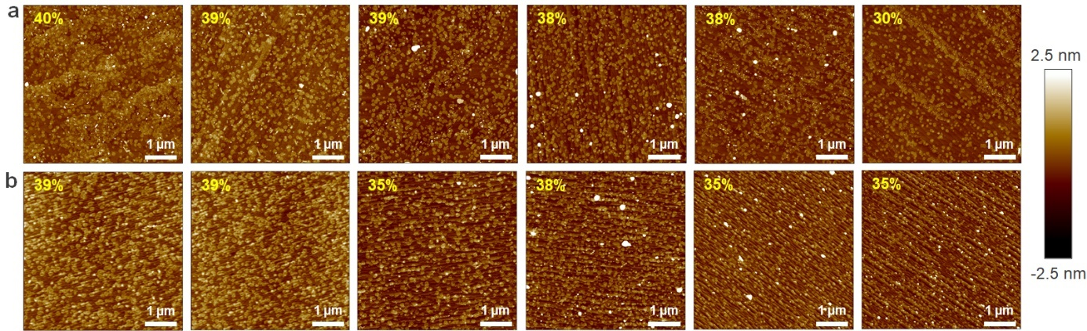

Figure S8. Surface coverage of the superficial islands on top of the fully coalesced monolayer MoS₂ on different kinds of sapphire templates. AFM topography maps of the 1.3 ML MoS₂ grown on 6 pieces of (a) on-axis and (b) off-axis 1º cut sapphire wafers, respectively. The 1.3 ML MoS₂ film consists of a fully closed monolayer and ~37% bilayer islands in both cases. The 1.3 ML MoS₂ samples here are all deposited under the same condition as explained in the Experimental Details.

Figure S9. RBS analysis of MOCVD 1.3 ML MoS₂ on different on-axis and off-axis 1º cut sapphire wafers. (a-c) Amount of the deposited Mo, calculated MoS₂ thickness and S/Mo ratio of the MoS₂ grown on different on-axis cut sapphire wafers. (d-f) Amount of the deposited Mo, calculated MoS₂ thickness and S/Mo ratio of the MoS₂ grown on different off-axis 1º cut sapphire wafers. µ, δ and C_{v} represent the mean value, standard deviation and coefficient of variation respectively. C_{v} is calculated through dividing the standard deviation by the mean value. In a perfectly crystalline monolayer MoS₂, the deposited Mo amount of 1.16 × 10¹⁵ atoms/cm².^{S2}

Figure S10. 1.3 ML MoS₂ grown on center and edge of different sapphire wafers. AFM topography of MoS₂ grown at (a) the center and (b) edge of on-axis cut sapphire. AFM topography of MoS₂ grown at (c) the center and (d) edge of the off-axis 1º cut sapphire.

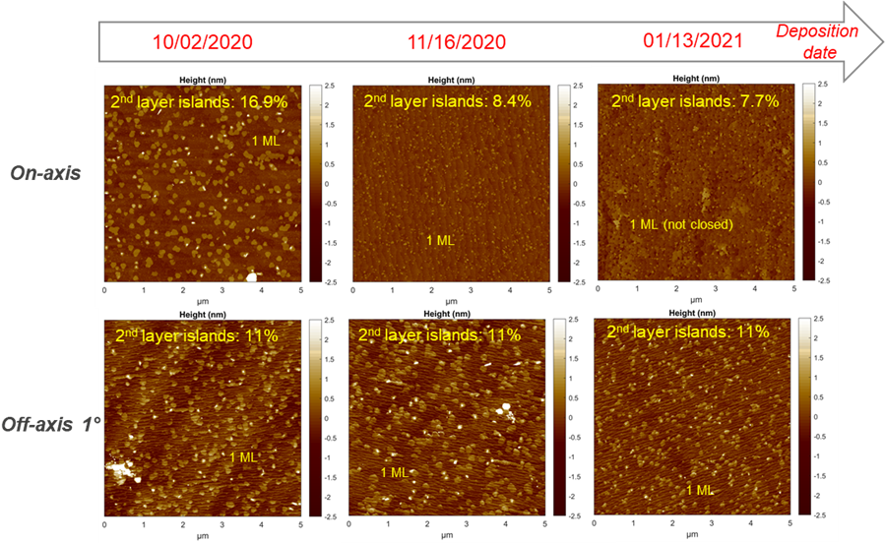
Figure S11. 1.1 ML layer MoS₂ deposited on on-axis (top ones) and off-axis 1º (bottom ones) cut sapphire wafers over time. All the deposition are performed with using the same growth recipe (under the same growth condition). The surface coverage of second layer islands on the MoS₂ deposited on on-axis cut sapphire varies from wafer to wafer, while it maintains the same for the material deposited on off-axis 1º cut sapphire. To be note that, the 1.1 ML MoS₂ here is deposited at a different growth condition compared to those 1.3 ML MoS₂ in the main text. The growth condition here is 7 min MoS₂ deposition of 67 sccm Ar:Mo(CO)₆, 100 sccm H₂S (carried by 20 slm N₂) at 1000 °C under a total pressure of 20 Torr. The flow rate of Mo(CO)₆ is 0.018 sccm.

Figure S12. Typical PL spectra of the 1.3 ML MoS₂ on 14 different sapphire substrates. PL spectra collected at different locations of the MoS₂ grown on on-axis (red) and off-axis 1º (blue) cut sapphire wafers. The features at 1.79 eV orginate from the sapphire substrates. All the PL spectra are collected under the same condition.

Figure S13. Raman spectra measurements on 1.3 ML MoS₂ grown on 16 pieces of on-axis and off-axis 1º cut sapphire wafers. Raman spectra characteristics of the MoS₂ grown on different pieces of (a-d) on-axis and (e-h) off-axis 1º cut sapphire wafers. (b, f) The full width half maximum (FWHM) of A_{1g} peak, (c, g) E_{2g}/A_{1g} ratio and (d, h) frequency difference between A_{1g} and E_{2g} peaks all show a narrower distribution for MoS₂ grown on off-axis 1º cut sapphire than that for MoS₂ grown on on-axis cut sapphire. µ, δ and C_{v} represent the mean value, standard deviation and coefficient of variation respectively.

The AFM topography of the closed 1.3 ML MoS₂ grown on on-axis cut sapphire shows variation at center and edge in Figure S10a-b, while it is very similar at center and edge of the off-axis 1º cut sapphire in Figure S10c-d. The average thickness and S:Mo ratio of the grown MoS₂ has been checked by RBS in Figure S11. The amount of Mo and S deposited during the MOCVD reaction is quantified in areal density (atoms/cm²) and the compositional ratio (i.e., S/Mo ratio) is calculated from the measured areal densities. As it can be observed in Figure S11, the calculated thickness of the epitaxial MoS₂ layer grown on both on-axis and off-axis 1º cut sapphire is very similar, which is around 0.8 nm. This corresponds to a fully closed 1st ML with ~30% 2nd-3rd layer crystals, which is consistent with the AFM topography in Figure S8. The S/Mo Ratio is around 2.15 and 2.03 for MoS₂ grown on on-axis and off-axis 1º cut sapphire, respectively. It is worth to note that the distribution of the S/Mo ratio of MoS₂ grown on different off-axis 1º cut sapphire is a bit narrower (C_{v} of 0.9%) than that of MoS₂ grown on different on-axis cut sapphire (C_{v} of 2.3%). This may indicate a more uniform distribution of the chemical composition for the MoS₂ grown on off-axis 1º cut sapphire. Even though the average thickness of the MoS₂ on on-axis and off-axis 1º cut sapphire is similar, the local thickness of the MoS₂ can behave differently. Figure S12 shows the typical PL spectra analysis of the MOS₂ grown on 14 pieces (7 each) of on-axis (red) and off-axis 1º (grey) cut sapphire wafers. As it can be observed, red curves are more diffused than the blues ones, indicating a larger thickness variation across the wafers for the MoS₂ grown on on-axis cut sapphire than that on off-axis 1º cut sapphire. In addition, Raman spectroscopy in Figure S13 reveals a larger difference between A_{1g} and E_{2g} peak position of 1.3 ML MoS₂ at different locations across the on-axis cut sapphire, indicating a large local thickness variation from wafer to wafer for the MoS₂ grown on on-axis cut sapphire (Figure S13).^{S3-S4}

Figure S14. XTEM image of 1.3 ML MoS₂ grown on on-axis cut sapphire. The image shows a 2nd layer of MoS₂ crystal originates from the presence of a step, which is not from the underneath 1st layer. At the present defocus, the bright contrast corresponds to layers of sulfur while the dark contrast corresponds to a layer of molybdenum.

Figure S15. PV-TEM images of 1.3 ML MoS₂. (a-b) Bright field (BF) TEM images of the MoS₂ grown on on-axis and off-axis 1º cut sapphire, respectively. The inset images in (a-b) are the selected area electron diffraction (SAED) patterns of the MoS₂. Colored circles in the SAED patten mark the position of the objective aperture while acquiring the DF-TEM image wherein the color corresponds to the false color used in the composite dark-field image. The MoS₂ was transferred from sapphire substrate to the TEM specimen grid prior to TEM inspection, see details in the Experimental Details.

Figure S16. (a) Composite DF-TEM image of 1.3 ML MoS₂ grown on on-axis cut sapphire. (b) Cropped image from region marked with red box in (a). (c) pannel (b) rebinned by 4 to reduce noise. Insets in bottom of (b) and (c) are integrated line profiles extracted from the regions marked with white arrows showing intensities of red and green channels. The white dashed lines outline the grain boundaries resulted by the 60º misoriented crystals.

Figure S16b shows a cropped region from Figure S16a (the same image as Figure 2c) centered on a 60° twinned domain. The predominant grain orientation (0°) has a slightly higher intensity of red compared to green while the 60° twin has a higher intensity of green compared to red. Although the color/intensity differences for stacking order are very drastic, the intensity variation is minor in case of monolayer and is overwhelmed by low signal to noise of the CCD. This makes it rather challenging to spot such a boundary at first glance. The DF-TEM images are rebinned (x4) to reduce noise and shown in Figure S16c.

Figure S17. Combined TOF-SIMS and AFM measurements at the same location of 1.7 ML WS₂ film on on-axis cut sapphire. (a) AFM topography and (b) TOF-SIMS maps collected at the same location of the sample. The TOF-SIMS map in (b) shows the overlay composition of Al₂O⁺ (in red) and WS⁺ (in green) clusters. It shows a non-uniform distribution of the Al₂O⁺ clusters all over the sample surface, and the non-uniformity is independent of layer thickness variation. This indicates the inhomogeneous distribution of Al₂O⁺ cluster is related to the varied sapphire surface termination all over the surface.

Figure S18. Correlated CAFM and Raman maps on as-deposited 1.3 ML MoS₂ on on-axis cut sapphire. (a) CAFM topography and (b) current maps on the sample, indicating regions with different conductivity all over the sample surface. The 1st layer MoS₂ is fully closed everywhere. (c-f) Raman maps in terms of E_{2g} position, A_{1g} and E_{2g} peak separation, E_{2g}/A_{1g} ratio and full width half maximum (FWHM) of A_{1g} peak of the MoS₂ sample, respectively.

We perform more experiments to further check the mechanism of inhomogeneous conductivity of 1.3 ML MoS₂ grown on sapphire. In Figure S18, we try to correlate the CAFM and Raman mapping characterization together on as-deposited 1.3 ML MoS₂. CAFM is firstly collected on the MoS₂ sample, which is with 1st layer fully closed and 2nd layer islands on top (as shown in Figure S18a). In the CAFM current map, regions with different conductivity are observed. After that, we make a scratch (regions marked with yellow dashed lines) near to the location where we did CAFM measurement, and then perform the Raman characterization at the same location (location found through the scratch). We observe non-uniform distribution of the Raman signals all over the surface in Figure S18d-f. It is hard to link the Raman signals with CAFM current features since the lateral resolution of these two techniques are different (around 1 µm for Raman, and <1 nm for CAFM). From the Raman characterizations, the signal of E_{2g} position is quite homogeneous in Figure S18c, indicating a homogeneous strain effect all over the sample surface, so most probably, the inhomogeneous conductivity of the MoS₂ on sapphire is not related to the strain effect (uniform all over the surface) introduced by non-uniform sapphire topography. The signal of E_{2g}/A_{1g} ratio and FWHM of A_{1g} peak shows correlated non-uniform signals, which are independent of the signals in the A_{1g} and E_{2g} peak separation map. This indicates the intrinsic doping effect all over the sample surface could be different.

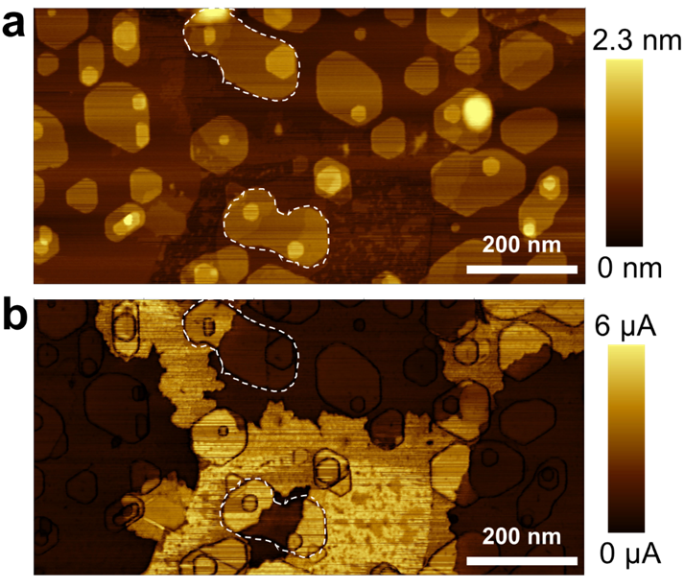

Figure S19. Electrical conductivity of 2nd-3rd layer MoS₂ crystals on the 1.3 ML MoS₂ grown on on-axis cut sapphire. (a) Topography and its corresponding (b) current map of the MoS₂ grown on on-axis cut sapphire. The white color outlines crystals show partial regions with higher conductivity and partial regions with lower conductivity, indicating that the superficial crystals don’t contribute to the imhomogeous conductivity of the MoS₂ on sapphire.

Figure S20. CAFM measurements on the MOCVD 1.5 ML MoS₂ film grown on on-axis cut sapphire under a different condition from that shown in the manuscript. CAFM (a) topography and (b) corresponding current maps at the same locations of the MoS₂ film. The MoS₂ grown at this new condition also shows regions with lower conductivity, i.e. dark regions in (b). The growth condition here is 10 min MoS₂ deposition of 67 sccm Ar:Mo(CO)₆, 100 sccm H₂S (carried by 19.98 slm N₂) at 1000 °C under a total pressure of 20 Torr. The flow rate of Mo(CO)₆ is 0.018 sccm.

Figure S21. Inhomogeneous electrical conductivity of 1.7 ML WS₂ grown on sapphire. (a-b) Topography and simultaneously obtained current map of 1.7 ML WS₂ on on-axis cut sapphire.

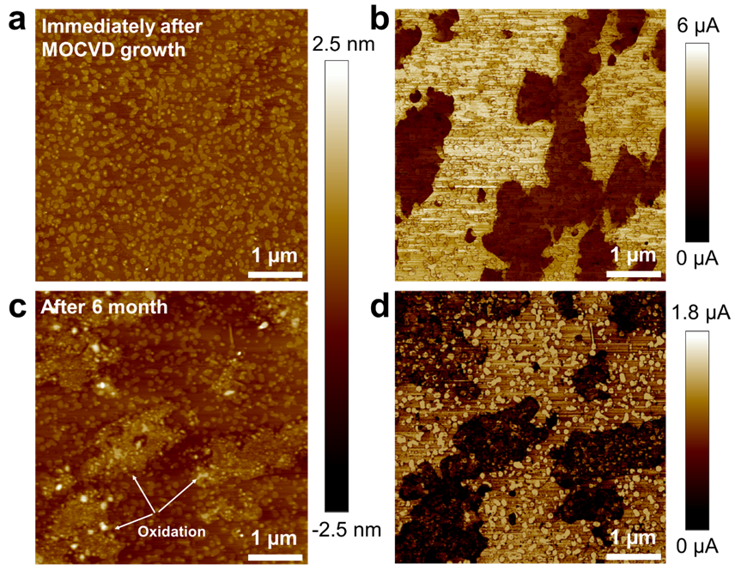

Figure S22. Degradation of 1.3 ML MoS₂ grown on on-axis cut sapphire. (a-b) Topography and its corresponding current map at 1 V of the 1.3 ML MoS₂ collected immediately after the MOCVD growth. (c-d) Topography and current map at 1 V of the same sample after 6 months storage in a N₂ cabinet. No oxidized regions in (a), but the MoS₂ are partially oxidized in (c), which always correlates to the poorly conductive regions in (d). The oxidized regions are thicker compared to the non-oxidized regions in (c).

Figure S23. Wet transfer process of the deposited MoS₂ from sapphire to SiO₂/Si substrates.

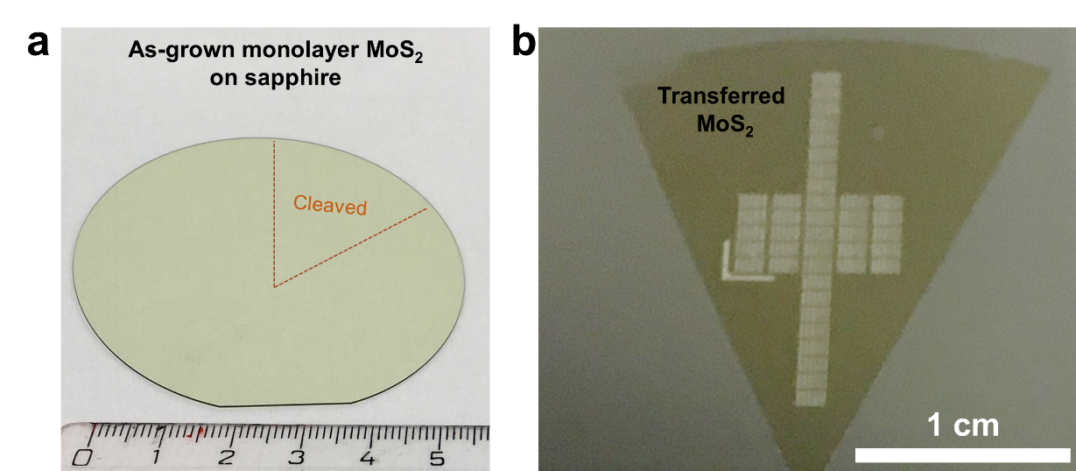

Figure S24. Digital images of the as-grown 1.3 ML MoS₂ on sapphire and the transferred MoS₂. Digital images of (a) as-grown 1.3 ML MoS₂ on a 2-inch sapphire wafer and (b) transistors fabricated on transferred MoS₂ on SiO₂/Si substrates. (b) shows the transistors are fabricated from center to edge of the transferred MoS₂ layer. The MoS₂ layer shown in (b) is cleaved from MoS₂ deposited on a 2-inch sapphire wafer, as indicated in (a), and then trnasferred to SiO₂/Si substrates. As shown in (b), our devices are located in a range of 1.9 cm (vertical) and 0.7 cm (horizontal). The devices located vertically actually include devices fabricated on the MoS₂ deposited at wafer center and edge. Our conclusions are made through comparing the performance of thousands of devices located in a range of centimeter scale, which covers the wafer center and edge.

Figure S25. Morphology and electrical performance of 1.3 ML MoS₂ transistors. SEM images of (a) the fabricated transistors with multiple L_{ch} and (b) a transistor with L_{ch} of 1.5 µm. (c) Forward curve of the transfer characteristics (V_{d} at 1V) of 1.3 ML MoS₂ transistors with L_{ch} from 1.5 µm to 20 µm. The MoS₂ was transferred from on-axis (red curves) and off-axis 1º (blue curves) cut sapphire to 50 nm SiO₂/p⁺-Si substrates.

Figure S25a-b show SEM image of the transferred 1.3 ML MoS₂ based transistors. The 1.3 ML MoS₂ can be observed clearly at the channel in Figure S25b, which shows a fully closed 1st monolayer MoS₂ and 2nd-3rd layer of MoS₂ crystals. Figure S25c shows the transfer characteristic curves (at $V_{ds}$ of 1 V) of ~2400 transistors fabricated on the 1.3 ML MoS₂ which was transferred from the on-axis (red curves) and off-axis 1º (blue curves) cut sapphire respectively. The L_{ch} ranges from 1.5 µm to 20 µm, and it can be observed that the transistors fabricated on the MoS₂ from the off-axis 1º cut sapphire show a much narrower distribution for the transfer characteristic curves, indicating a lower device-to-device variability. The highest I_{d} of the devices fabricated on the transferred MoS₂ from the on-axis and off-axis 1º cut sapphire are ~38 µA/µm. The I_{d} decreases with the L_{ch}, which should be due to more local defects (including grain boundaries) for the longer MoS₂ channels. The µ_{FE} of the transistors is calculated through the equation $µ_{FE}=g_{m}L_{ch}{(W_{ch}C_{ox}V_{ds})}^{-1}$,^{S5} where $g_{m}$ is the maximum transconductance ($g_{m}= ∂I_{d}/∂V_{g}$) and $C_{ox}$ is the back gate oxide capacitance per unit area ($C_{ox}$= 0.69 µF/cm² for 50 nm SiO₂). The V_{t} is extracted through the constant current method.^{S6} The subthreshold swing (SS) is defined by $SS={\left[\frac{dlog\left(I_{D}\right)}{dV_{G}}\right]}^{-1}$, SS_{min} is extracted at the minimum value of it.

Figure S26. Reusability of the sapphire templates after MoS₂ transfer. (a) Digital image of a 2-inch on-axis cut sapphire wafer after MoS₂ delamination in Figure S23. We have intensively kept the MoS₂ at the edges of the wafer, in order to have a better comparison of the regions with and without MoS₂ transfer (white and slightly yellow regions). (b) AFM topography map collected at one region (red square outlined) after MoS₂ delamination in (a). Clean and clear terrace structure can be observed in (b).
Figure S27. Device-to-device variability of 1.3 ML MoS₂ transistors by aggregating the data from all the repeated experiments together in Figure 4. (a) I_{d} at a fixed carrier density of 10¹³ cm⁻², (b) SS_{min}, (c) V_{t}, (d) I_{max}/I_{min} ratio and (e) µ_{FE} for the MoS₂ transistors with different L_{ch}. The red and blue symbols indicate the 1.3 ML MoS₂ was transferred from on-axis and off-axis 1º cut sapphire, respectively.

Figure S28. Extended Statistical comparison of device-to-device variability of 1.3 ML MoS₂ transistors from different sapphire substrates. CDF plots in the aspect of I_{d} at constant carrier density, SS_{min}, V_{t}, I_{max}/I_{min} and µ_{FE} of the devices with L_{ch} of (a-j) 2 µm, 2.5 µm, 3 µm, 4 µm, 5 µm, 7 µm, 10 µm, 12 µm, 15 µm and 20 µm, respectively.

Figure S29. Device-to-device variability comparsions through C_{v} values. (a-e) C_{v} values of the devices perfomance in terms of I_{d}_n, SS_{min}, V_{t}, I_{max}/I_{min} and µ_{FE} as function of the channel lengths. The red symbols represent transistors fabricated on MoS₂ from on-axis cut sapphire, while the blue symbols represent transistors fabricated on MoS₂ form off-axis 1º cut sapphire.

Performance | On-axis (C_{V}) | Off-axis 1º (C_{V}) | On-axis (C_{V})_average | Off-axis 1º (C_{V})_average
I_{d}_n | 27%-69.7% | 22.06%-26.3% | 48.1% | 24.1%
SS_{min} | 39.5%-85.9% | 12.5%-33.1% | 65.2% | 23.9%
V_{t} | 61.6%-76.5% | 22.2%-42.5% | 65.5% | 26.8%
I_{max}/I_{min} | 84.2%-110.2% | 24.7%-40.8% | 97% | 31.9%
µ_{FE} | 27.9%-67.3% | 17.6%-29.5% | 47.9% | 24.3%

Table S1. Extracted device-to-device variability of transistors fabricated on 1.3 ML MoS₂ from on-axis and off-axis 1º cut sapphire. The device-to-device variability is defined as coefficient of variation (C_{v}) here, which is calculated through dividing the standard deviation by the mean value. The C_{v} values are extracted from Figure S29 based on the CDF plots in Figure 5a-j and Figure S28. In terms of I_{d}_n, SS_{min}, V_{t}, I_{max}/I_{min} and µ_{FE,} the C_{v} values all decrease through introducing the off-axis 1º cut sapphire.

Table S2. Performance (at the best case) comparison of monolayer/bilayer MoS₂ based transistors in this work with previously reported ones.

Synthetic method | Thickness (layer) | Channel length (μm) | Gate dielectric | I_{on} (μA/μm) | I_{max}/I_{min} | Mobility (cm²/V s) | Reference
MOCVD | 1 | 1.5 | 50 nm SiO₂ | 38 | 2 × 10¹⁰ | 40 (median 18) | this work
MOCVD | 1 | 10 | 270 nm SiO2 | 0.03 | - | 22 | S7
MOCVD | 1 | 1.6 | 285 nm SiO2 | ~1 | 10⁶ | 30 | S8
CVD | 1 | 6 | 30 nm Al₂O₃ | 35 | 10¹⁰ | 55 | S9
CVD | 1 | 0.1 | 2 nm HfO_{X} | 390 | 4 × 10⁸ | - | S10
CVD | 1 | 10 | 35 nm Al₂O₃ | 6 | 10⁸ | 70 | S11
CVD | 1 | 2 | 300 nm SiO₂ | 18 | 10⁶ | 167 | S12
CVD | 1 | 4 | 20 nm Al₂O₃ | 16.7 | 10⁸ | 30 | S13
CVD | 2 | 0.04 | 70 nm HfLaO | 427 | 10⁶ | 36 | S14
CVD | 1 | 0.072 | 30 nm SiO₂ | 320 | 3.2 × 10⁹ | 35 | S15
CVD | 1 | 0.05 | 5 nm HfO₂ | 250 | 3.5 × 10⁷ | - | S16
CVD | 1 | 0.008 | 6 nm HfO₂ | 2.7 | 10⁶ | 1.1 | S17
CVD | 1 | 1 | 285 nm SiO₂ | 49 | 10⁷ | 64 | S18
CVD | 2 | 2 | 22 nm Al₂O₃ | 26 | 10⁸ | 3 | S19
CVD | 1 | 5 | 30 nm SiO₂ | 18 | 10⁷ | 42 | S5
CVD | 1 | 0.01 | 5-6 nm Al₂O₃ | 426 | 10³ | 30 | S20
CVD | 1 | 20 | 300 nm SiO₂ | 0.14 | 10⁶ | 7 | S21
CVD | 1 | 0.1 | 285 nm SiO₂ | 62.5 | 10⁴ | 13 | S22
Exfoliated | 1 | 1.9 | 15 nm h-BN | 44 | 2.2 × 10⁹ | - | S23
Exfoliated | 1 | 2 | 30 nm Al₂O₃ | 450 | 10⁷ | 41 | S24
Exfoliated | 1 | 0.01 | 300 nm SiO₂ | 540 | 10⁶ | 26.7 | S25
Exfoliated | 2 | 0.001 | 5.8 nm ZrO₂ | 30 | 10⁶ | - | S26
Exfoliated | 1 | 1.2 | 100 nm SiO₂ | 85 | 10⁷ | 48 | S27
Exfoliated | 1 | 0.5 | 30 nm HfO₂ | 320 | 10⁸ | 60 (250K) | S28

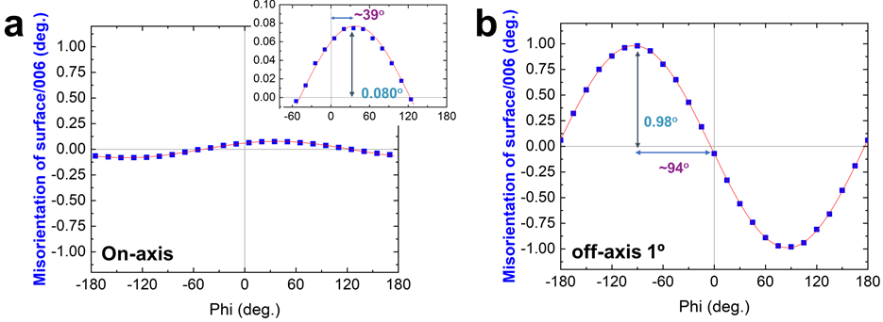

Figure S30. Measurements of the actual off-axis cut angle of on-axis and off-axis 1º cut sapphire. XRD measurements of (a) on-axis and (b) off-axis 1º cut sapphire. The measured 0.08º and 0.98º is consistent with the off-axis cut angle of on-axis (0º, ± 0.1º) and off-axis (1º, ± 0.1º) cut sapphire.

Supplementary references

- Hayashi, Y.; Banal, R. G.; Funato, M.; Kawakami, Y. Heteroepitaxy between Wurtzite and Corundum Materials. J. Appl. Phys. 2013, 113, 183523.
- Groven, B.; Heyne, M.; Mehta, A. N.; Bender, H.; Nuytten, T.; Meersschaut, J.; Conard, T.; Verdonck, P.; Van Elshocht, S.; Vandervorst, W.; De Gendt, S.; Heyns, M.; Radu, I.; Caymax, M.; Delabie, A. Plasma-Enhanced Atomic Layer Deposition of Two-Dimensional WS₂ from WF₆, H₂ Plasma, and H₂S. Chem. Mater. 2017, 29, 2927−2938.
- Shahzad, R. Kim, T. Kang, S.-W. Effects of Temperature and Pressure on Sulfurization of Molybdenum Nano-Sheets for MoS₂ Synthesis. Thin Solid Films 2017, 641, 79–86.
- Liang, L. Meunier, V. First-Principles Raman Spectra of MoS₂, WS₂ and Their Heterostructures. Nanoscale 2014, 6, 5394–5401.
- Smithe, K. K. H.; Suryavanshi, S. V.; Muñoz Rojo, M.; Tedjarati, A. D.; Pop, E. Low Variability in Synthetic Monolayer MoS₂ Devices. ACS Nano 2017, 11, 8456–8463.
- Ortiz-Conde, A. Garcı́a Sánchez, F. J. Liou, J. J. Cerdeira, A. Estrada, M. Yue, Y. A Review of Recent MOSFET Threshold Voltage Extraction Methods. Microelectron. Reliab. 2002, 42, 583–596.
- Cun, H.; Macha, M.; Kim, H.; Liu, K.; Zhao, Y.; LaGrange, T.; Kis, A.; Radenovic, A. Wafer-Scale MOCVD Growth of Monolayer MoS₂ on Sapphire and SiO₂. Nano Res. 2019, 12, 2646–2652.
- Kang, K.; Xie, S.; Huang, L.; Han, Y.; Huang, P. Y.; Mak, K. F.; Kim, C.-J.; Muller, D.; Park, J. High Mobility Three-Atom-Thick Semiconducting Films with Wafer-Scale Homogeneity. Nature 2015, 520, 656–660.
- Li, N.; Wang, Q.; Shen, C.; Wei, Z.; Yu, H.; Zhao, J.; Lu, X.; Wang, G.; He, C.; Xie, L.; Zhu, J.; Du, L.; Yang, R.; Shi, D.; Zhang, G. Large-Scale Flexible and Transparent Electronics Based on Monolayer Molybdenum Disulfide Field-Effect Transistors. Nat. Electron. 2020, 3, 711–717.
- Chou, A.-S.; Shen, P.-C.; Cheng, C.-C.; Lu, L.-S.; Chueh, W.-C.; Li, M.-Y.; Pitner, G.; Chang, W.-H.; Wu, C.-I.; Kong, J.; Li, L.-J.; Wong, H.-S. P. High On-Current 2D nFET of 390 µA/µm at V_{DS}= 1V Using Monolayer CVD MoS₂ without Intentional Doping. In 2020 IEEE Symposium on VLSI Technology; IEEE: Honolulu, HI, USA, 2020; pp 1–2.
- Li, N.; Wei, Z.; Zhao, J.; Wang, Q.; Shen, C.; Wang, S.; Tang, J.; Yang, R.; Shi, D.; Zhang, G. Atomic Layer Deposition of Al₂O₃ Directly on 2D Materials for High-Performance Electronics. Adv. Mater. Interfaces 2019, 6, 1802055.
- Wang, Y.; Kim, J. C.; Wu, R. J.; Martinez, J.; Song, X.; Yang, J.; Zhao, F.; Mkhoyan, A.; Jeong, H. Y.; Chhowalla, M. van der Waals Contacts between Three-Dimensional Metals and Two-Dimensional Semiconductors. Nature 2019, 568 , 70–74.
- Yu, L.; El-Damak, D.; Ha, S.; Ling, X.; Lin, Y.; Zubair, A.; Zhang, Y.; Lee, Y.-; Kong, J.; Chandrakasan, A.; Palacios, T. Enhancement-Mode Single-Layer CVD MoS₂ FET Technology for Digital Electronics. In 2015 IEEE International Electron Devices Meeting (IEDM); IEEE: Washington, DC, USA, 2015; pp 32.3.1-32.3.4.
- Gao, Q.; Zhang, Z.; Xu, X.; Song, J.; Li, X.; Wu, Y. Scalable High Performance Radio Frequency Electronics Based on Large Domain Bilayer MoS₂. Nat. Commun. 2018, 9 , 4778.
- Smithe, K. K. H.; English, C. D.; Suryavanshi, S. V.; Pop, E. High-Field Transport and Velocity Saturation in Synthetic Monolayer MoS₂. Nano Lett. 2018, 18, 4516–4522.
- Zhu, Y.; Li, Y.; Arefe, G.; Burke, R. A.; Tan, C.; Hao, Y.; Liu, X.; Liu, X.; Yoo, W. J.; Dubey, M.; Lin, Q.; Hone, J. C. Monolayer Molybdenum Disulfide Transistors with Single-Atom-Thick Gates. Nano Lett. 2018, 18, 3807–3813.
- Xu, K.; Chen, D.; Yang, F.; Wang, Z.; Yin, L.; Wang, F.; Cheng, R.; Liu, K.; Xiong, J.; Liu, Q.; He, J. Sub-10 nm Nanopattern Architecture for 2D Material Field-Effect Transistors. Nano Lett. 2017, 17, 1065–1070.
- Sun, L.; Leong, W. S.; Yang, S.; Chisholm, M. F.; Liang, S.-J.; Ang, L. K.; Tang, Y.; Mao, Y.; Kong, J.; Yang, H. Y. Concurrent Synthesis of High-Performance Monolayer Transition Metal Disulfides. Adv. Func. Mater. 2017, 27, 1605896.
- Wachter, S.; Polyushkin, D. K.; Bethge, O.; Mueller, T. A Microprocessor Based on a Two-Dimensional Semiconductor. Nat. Commun. 2017, 8, 14948.
- English, C. D.; Smithe, K. K. H.; Xu, R. L.; Pop, E. Approaching Ballistic Transport in Monolayer MoS₂ Transistors with Self-Aligned 10 nm Top Gates. In 2016 IEEE International Electron Devices Meeting (IEDM); IEEE: San Francisco, CA, USA, 2016; pp 5.6.1-5.6.4.
- Zhang, J.; Yu, H.; Chen, W.; Tian, X.; Liu, D.; Cheng, M.; Xie, G.; Yang, W.; Yang, R.; Bai, X.; Shi, D.; Zhang, G. Scalable Growth of High-Quality Polycrystalline MoS₂ Monolayers on SiO2 with Tunable Grain Sizes. ACS Nano 2014, 8, 6024–6030.
- Liu, H.; Si, M.; Najmaei, S.; Neal, A. T.; Du, Y.; Ajayan, P. M.; Lou, J.; Ye, P. D. Statistical Study of Deep Submicron Dual-Gated Field-Effect Transistors on Monolayer Chemical Vapor Deposition Molybdenum Disulfide Films. Nano Lett. 2013, 13, 2640–2646.
- Zheng, X.; Calò, A.; Albisetti, E.; Liu, X.; Alharbi, A. S. M.; Arefe, G.; Liu, X.; Spieser, M.; Yoo, W. J.; Taniguchi, T.; Watanabe, K.; Aruta, C.; Ciarrocchi, A.; Kis, A.; Lee, B. S.; Lipson, M.; Hone, J.; Shahrjerdi, D.; Riedo, E. Patterning Metal Contacts on Monolayer MoS₂ with Vanishing Schottky Barriers Using Thermal Nanolithography. Nat. Electron. 2019, 2, 17–25.
- Yu, Z.; Zhu, Y.; Li, W.; Shi, Y.; Zhang, G.; Chai, Y.; Wang, X. Toward High-Mobility and Low-Power 2D MoS₂ Field-Effect Transistors. In 2018 IEEE International Electron Devices Meeting (IEDM); IEEE: San Francisco, CA, USA, 2018; pp 22.4.1-22.4.4.
- Xie, L.; Liao, M.; Wang, S.; Yu, H.; Du, L.; Tang, J.; Zhao, J.; Zhang, J.; Chen, P.; Lu, X.; Wang, G.; Xie, G.; Yang, R.; Shi, D.; Zhang, G. Graphene-Contacted Ultrashort Channel Monolayer MoS₂ Transistors. Adv. Mater. 2017, 29, 1702522.
- Desai, S. B.; Madhvapathy, S. R.; Sachid, A. B.; Llinas, J. P.; Wang, Q.; Ahn, G. H.; Pitner, G.; Kim, M. J.; Bokor, J.; Hu, C.; Wong, H.-S. P.; Javey, A. MoS₂ Transistors with 1-Nanometer Gate Lengths. Science 2016, 354, 99–102.
- Kappera, R.; Voiry, D.; Yalcin, S. E.; Branch, B.; Gupta, G.; Mohite, A. D.; Chhowalla, M. Phase-Engineered Low-Resistance Contacts for Ultrathin MoS₂ Transistors. Nat. Mater. 2014, 13, 1128–1134.
- Lembke, D.; Kis, A. Breakdown of High-Performance Monolayer MoS₂ Transistors. ACS Nano 2012, 6, 10070–10075.

